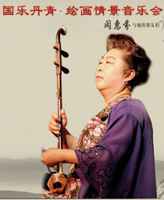
http://www.juooo.com/uploads/perform/20120814195602685.jpg
2012.8.26 赴深圳演出

