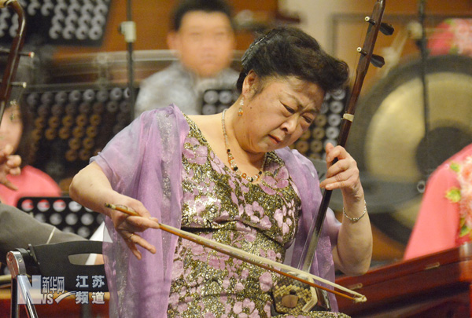
http://www.js.xinhuanet.com/xin_wen_zhong_xin/2012-06/01/xinsrc_5830609011139031296063.jpg
2012.6.1.赴南京演出

