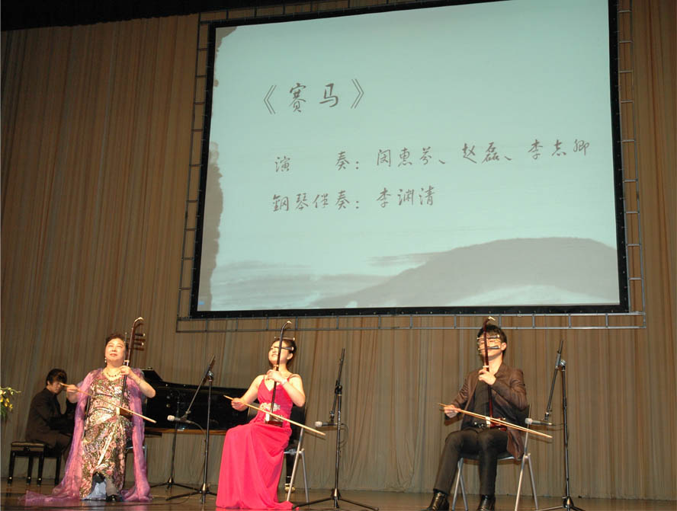
http://www.dunhuang-yueqi.com/UploadFile/image/2012050314174377106.jpg

2012.5.3出席敦煌国乐系列讲座

