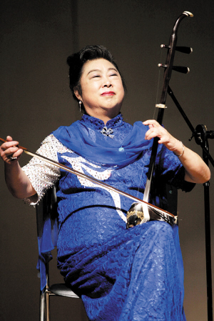
http://www.mask9.com/sites/default/files/mt0x0001/10042/image/20120401/people-erhu-performer-minhuifen-mask9.jpg
2012.4.25.出席台北市传统艺术季放纵的两根弦音樂會

