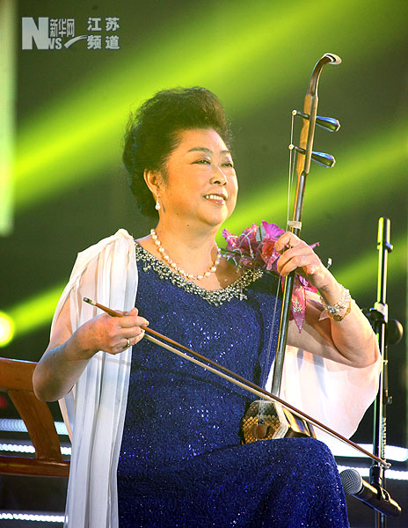
http://www.js.xinhuanet.com/2012-11/10/c_113655380.htm
2012.11.10 赴宜興演出
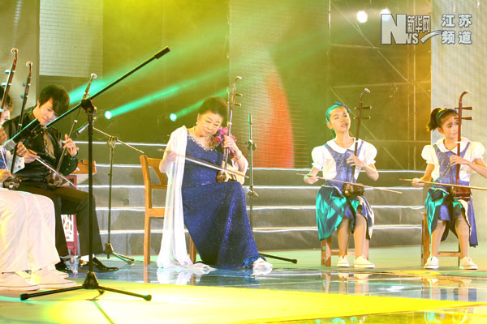

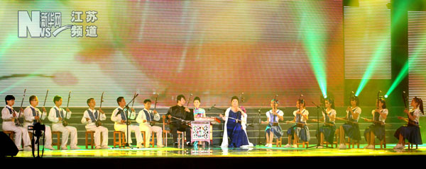
http://www.js.xinhuanet.com/2012-11/10/c_113655380.htm
2012.11.10 赴宜興演出

