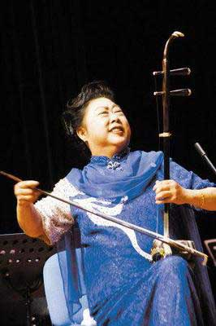
http://music.chinese.cn/image/attachement/jpg/site2/20100412/0023ae9af0dc0d2d19ca0a.jpg
2010.4.12.赴天津出席國樂盛典音樂會

